Frequently Asked Questions

- Can I throw out the ePAR self-registration document? Will I have to use that link again?
- Once you have registered, you can throw out the paper. No, you won’t have to use that link again. After registering, you can just go to: www.nj.gov and login.

- I keep getting error messages when I try to link the ePAR.
  - Did you check that the link was entered exactly as it appears? https://wwwnet1.state.nj.us/NJ/NJ_ePar_Reg/SelfRegistration.aspx
  - If your ID starts with NS did you enter in a birthdate of 01/01/1990?
  - If your ID starts with NS did you enter your First and Last Name in CAPS? You need to (it’s the only place CSC requires it).
  - If it still doesn’t work, contact Yvonne Catino at ycatino@kean.edu
- Once I’m registered, what page do I start on in the User Guide?
- Page 2 to log on the ePAR system

- As I move through the process, can I alter any part of the goals or expectations once the Employee has electronically signed?
- No changes can be made once the employee has electronically signed. However, if something needs to be added, use the Significant Events icon on the ribbon. The employee is required to sign off on any event added.

- Is there a place where I can record issues or events?
- Use the Notes section on the upper ribbon or Significant Events. The Notes section will be deleted at the end of the performance year and is only viewable to the supervisor. Significant Events are viewable to both supervisor and employee, and become part of their performance record.

- How do I print the Job Expectations or any other part of the PAR?
- The print instructions are on page 43 of the User Guide. Remember that the print button becomes enabled only when Rater submits the job expectations and the status of the record shows as shared on Rater dashboard.

- Why is the Managing Administrative Assistant title still completed on paper?
- The Civil Service Commission does not yet recognize that title due to Union agreements. Employees with this title will need to have their PARs completed on paper. It is the ONLY title that can be completed on paper.

- How does the Ratee sign the Job Expectations?
- Page 21 of the User Guide provides steps needed to complete the Job Expectations section.

- Why are boxes at the top of the User Guide marked Ratee, Rater, Reviewer, All Parties? What does that mean?
- The User Guide was written to accommodate all parties involved in the ePAR process. If you are a Rater, you would follow along the Rater marked pages. Similarly, if you are a Ratee, you follow the Ratee marked pages.

- Will the Rater have the ability to make changes to the Job Expectations, if need be, after the face to face meeting?
- Yes.

- My ePAR is not showing up when I log on to www.nj.gov. What do I do?
- If you do not see the ePAR that means you have not linked the two state systems. Please start with the self-registration document that is located under the ePAR Documents section: http://www.kean.edu/offices/human-resources/performance-evaluations

- I received an error message that says “the information does not match”, what do I do?
- This usually means that there is an incorrect ID, name is spelled differently in the system and/or email does not match. Please contact Tameeka Upshaw at tupshaw@kean.edu.

- What does the Rater do if a Ratee is not listed?
- Email Tameeka Upshaw at tupshaw@kean.edu

- What if one of my Ratees is on medical or disability leave?
- Raters would wait until they come back from leave. If the employees are in PMIS and their leave is entered correctly, then on ePAR the Leave flag will turn on.

- As a Rater, can I print out Notes?
- You cannot print Notes.

- What are the system time-out guidelines?
- There are 3 distinct timeout scenarios for ePAR:
- 1 - 30 minutes of inactivity times a user out of myNJ.
- 2 – Two hours maximum myNJ session then a user is timed out of myNJ.
- 3 - ePAR has a 2 hour maximum session. (This timer starts when either ePAR is first called or if another proxy’d application is first called. Proxy’d applications share their session timeout.)
- Our advice is for a user to start a new myNJ session and go immediately into ePAR to eliminate any unforeseen timeouts. That gives you a full 2 hours of ePAR work time.

- I keep getting these page errors. What do I do to make them stop?

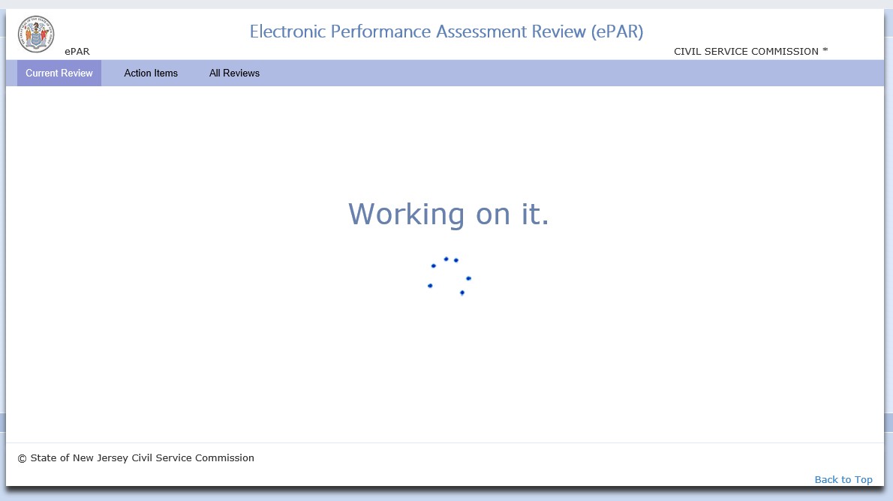

- Hit the F5 key to refresh the page to see if that clears up any loading issues.
18. How do I close out a PAR?
- Go to page 58 of the User Guide and follow the procedures.
19. Why can’t I sign off on my PAR?
- More than likely your supervisor has not completed the Face to Face signoff in ePAR. Your supervisor must complete that action before you can sign.
20. Why do I keep getting these email notifications saying my ePAR is late?
- This is a state system, not a Kean system. The emails go out to everyone who is on a non-compliance report. Meaning, if you and your supervisor completed your parts and the reviewer has not, all three of you will receive the notification. Raters are responsible for the process and thus should stay abreast of where their ratees’ ePARs are in process. Further, Raters can always check their dashboards to see status.

